NOMINATION FORM: Global Business & Interfaith Peace Awards

Note: Nominations are open to CEOs (present or past) of companies who have championed interfaith understanding and peace.

Nominee Contact Information

- Nominee Full Name: Andy Showell-Rogers
- Corporate Title: CEO/Managing Director, UK
- Company Name: Visible Clothing Company
- Company Headquarters Location (Country): Oxford, UK
- CEO’s contact (personal assistant name): Stephanie Harper
- CEO’s contact (personal assistant email): Stephanie@visibleclothingcompany.com
- CEO’s contact (personal assistant phone): +447402824353
- Company website: www.visible.clothing & www.eternalcreation.com
- Engagement with the UN Global Compact and/or the Religions Freedom & Business Foundation*
☐Company is a signatory of the UN Global Compact
☐Company has joined Business for Peace
☐Company has signed the Religious Freedom & Business Foundation’s pledge to protect freedom of religion
X Company intends to join one or more of the initiatives listed above in the next six months, please specify Company is accessing the options for longer-term partnerships

* Nominees are invited to:
- join the UN Global Compact and its Business for Peace platform and,
- make the Religious Freedom & Business Foundation's corporate pledge to protect freedom of religion or belief (FoRB)

Nominator Contact Information

- Nominator Full Name: Andy Lower
- Nominator Title: Founder
- Nominator Company Name: ADAP Capital LLC
- Nominator Email Address: andylower@adapcapital.com
- Nominator Phone Number: +1-610-235-7804
- Nominator Relationship to the Nominee: Business Colleague, Investor, Friend

Please submit a Biography of the Nominee (max 200 words)
Andy Showell-Rogers is CEO/Managing Director and Co-Founder of the Visible Clothing Company. Visible Clothing Company owns and operates a culturally and religiously diverse fair trade garment factory in Dharamsala, India, employing an ethically and religiously diverse work force and seeks to find multiple ways of people to fulfill their potential in a safe and empowering work place. Additionally, Visible has two ethical fashion labels - www.visible.clothing and www.eternalcreation.com

Visible makes it easier for consumers who want to buy in line with their values by making the people and processes behind the clothes visible. Visible communicates how much the clothes cost to make so customers can judge whether they are being charged a fair price. In addition, Visible reminds customers that clothes are made by people who have dreams and goals like you and me, they are not faceless and are trying to do the best for their families like we are. Lastly, Visible makes clear the positive impact that occurs when consumers choose to buy in line with our values.

Andy has a MA in Human Resource Management (with distinction) from Oxford Brookes and a BA in Management Sciences from Southampton University.

Information about the policy, programme or initiative
Note: If the CEO has supported an interfaith understanding and peace initiative philanthropically or done things in his/her personal capacity to advance interfaith understanding and peace, please describe the philanthropic or personal initiative. If the company has done the interfaith understanding and peace work, then describe what the company headed by the CEO has done). See case studies from 2016 for examples: http://religiousfreedomandbusiness.org/business-case-studies-templeton-religion-trust

- Please describe a policy(s), programme(s) or initiative(s) that the Nominee (or the company the Nominee leads/led) has launched or spearheaded to advance the company’s efforts to champion interfaith understanding and peace (max 300 words)
One of Andy’s primary contributions to the organization in this content, has been the writing, rewriting and implementation of a values driven HR policy manual. Applying various lens to the manual has allowed management, owners and the work force to work cohesively together. Andy has brought his strong Christian faith to this process and the knock on effects of agreeing to the blue print for the organization that he is leading, have been huge. Working with Tibetan, Hindu and Muslims faiths can often prove difficult and can easily be exploited for traditional approaches of favoritism. Having a culture where everything is being made visible has changed the organization from a preference based approach to a embracing an inclusive and ‘fairnesss' culture. The HR Manual has proven to be the back bone of the organization and has been used to drive effectiveness as well to generate additional financial investment to fuel the organization’s growth.

- Which category or categories does the policy(s), programme(s) or initiative(s) fall into:
X Core business
☐Social investment & philanthropy
☐Advocacy and public policy engagement
☐Partnership and collective action

- Does the policy(s), programme(s) or initiative(s) address any of the following related to Freedom of Religion or Belief (FoRB):
X Promote sustainable and innovative business through protecting Freedom of Religion or Belief (FoRB)
X Non-discrimination and/or non-harassment on the basis of religion or belief
X Religious accommodation and inclusion
X Protecting and promoting freedom of religion or belief (FoRB) in the community
☐Other (describe below, max. 25 words)

- Please describe the objective of the policy(s), programme(s) or initiative(s) and the need, goal or gap that it was designed to address. (max 200 words)
Visible acquired a fair trade certified factory in January 2016 and it was a work environment riddled with minor corruption and a culture that was not intent on empowering or respecting the workforce. Religious presences were paramount in major decision making processes and lead to a demoralized and suspicious-based working environment. Over many months and hours of listening to various stakeholders, bold decisions were made under Andy’s leadership to change the management and train a new generation of leaders. Additionally the changes to the hiring and firing processes then developed a new inclusive approach, building on Andy’s vast experiences of working with teams all around the world in various religiously diverse circumstances.

- How was the policy(s), programme(s) or initiative(s) implemented? What role did the Nominee play? (max 200 words)
Andy led the charge that brought about wholesale changes, the vast majority of which have not been publicly shared. He worked tirelessly at great financial and personal cost to ensure that the workforce was being treated fairly and beyond simply ensuring that boxes were being ticked, he focused on making sure that everyone felt that they, and significantly their religious views, were being respected.

- What were/are the most persistent challenges in implementing the policy(s), programme(s) or initiative(s)? How were they/are they being overcome and what was the role of the Nominee? (max 200 words)
Behavioral change is always hard and overcoming negative culture norms can take time. While a belief of mutual respect is inherent in most people’s beliefs, when that respect has been abused, incredible patience and wisdom is required to overcome that and develop new approaches. Andy had the necessary leadership qualities and worked tireless to set the culture of the organization as one that was built on core values aligned with the overarching mission of a clothing sector where everyone is treated fairly.

- What are the key lessons learned from launching the policy(s), programme(s) or initiative(s)? (max 200 words)
Patience and respect.

Impact and Reporting on Progress

- How do you monitor and evaluate progress on the policy(s), programme(s) or initiative(s)? If relevant, what indicators and metrics are used? (max 200 words)
One year ago the company took on its first working capital loan and had criteria that ensured that the company was inclusive in its approach. Failure to be inclusive would trigger various penalty clauses that would make the loan interest increase considerable. Additionally, the company reports regularly to its investors on the key performance indicators (KPIs) and on progress to achieve milestones to growth. As an organization there are various mechanisms that are set up internally that provide ways for team members to review and assess success.

- What outcomes or impact have been reached to date? Please be as specific as possible and supply available data. (max 200 words)
Visible has developed an incredibly high employee retention rate and has ensured that all the workers are paid a salary in line with their abilities and attitude regardless of religion. Applying the lens of “fairness” has ensured that the business has grown and has a sustainable path to continue to develop and grow the current work force, as well as employing more workers in the longer term. The establishment of the fair trade committee that intentionally had inclusion at the core has also been pivotal to ensure that the work force comes together as a cohesive team.

- Is the Nominee’s company reporting on its practices, policies, programmes and/or initiatives to champion interfaith understanding and peace? If so, please provide relevant weblink(s) for posting on the Awards’ website. If integrated into the company’s corporate sustainability report, Global Compact COP or GRI Report, please indicate relevant pages and/or sections. (max 200 words)
Visible is self-reporting on its two websites - www.visible.clothing and www.eternalcreation.com and will be releasing an annual report at the end of 2017.

Additional Information:

- Are there additional actions the Nominee has taken on an individual level to support interfaith understanding and peace within the organization? If so, please specify. (max 200 words)
Andy has brought his extensive work in HR management, both in the UK and abroad in charitable and socially responsible organizations, implementing all aspects of modern HR methodologies, government legislation and industry best practice, and is able to consistently deliver first class results. He has used his incredible talents to manage, motivate and inspire a diverse team with a genuine passion and enthusiasm for delivering a safe, fair and equitable environment for all workers, building rapport quickly with clients, colleagues and stakeholders to promote a positive and trusting working relationship where all parties are able to achieve their goals. His ability to listen and then to translate into specific actions has ensured that individuals feel part of the process and are included in the long term growth of the company.

- How has the Nominee taken action to support and promote the UN Global Compact’s Ten Principles? If so, please specify. (max 200 words)
Andy’s faith motivation means that he has a core believe in Human Rights for all those who he works with, as well as to build a community at the work force that makes treating others in line with the ‘golden rule’ at the centre of the company. Collective bargaining was less focused on negotiation and tactical maneuvers but on listening, reflecting and trying to access what was in the mutually beneficial best interests. Changing the thinking to collective collaboration has reduced tension between team-mates and removed the barriers to being focused on the higher level vision.
The #zeroWaste production strategy has allowed the work force, that represents a variety of religions, to be working at a facility that has the respect for the environment that they have all agreed with in their mutual values.
Direct and (most importantly) honest conversations has meant that corruption within the organization has been addressed and means that as a team working with outside 3rd parties the same levels of honesty and integrity are expected and respected.

- Please attach a headshot photo of the Nominee and any video or other supporting materials to the email with this nomination form. We will look to use these and other materials we may request for a video of your Nominee if he/she is a top finalist.
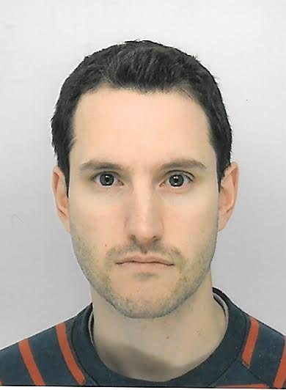

Please provide any additional information to be considered. If you have any questions or concerns, please contact the Nominations team nominations@religiousfreedomandbusiness.org

Sh

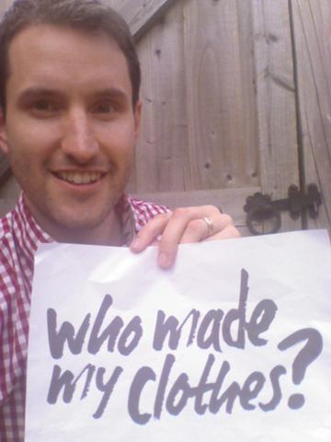

Article 18 of the United Nations Universal Declaration of Human Rights states: “Everyone has the right to freedom of thought, conscience and religion; this right includes freedom to change his religion or belief, and freedom, either alone or in community with others and in public or private, to manifest his religion or belief in teaching, practice, worship and observance.”

